Day 14

Task 01

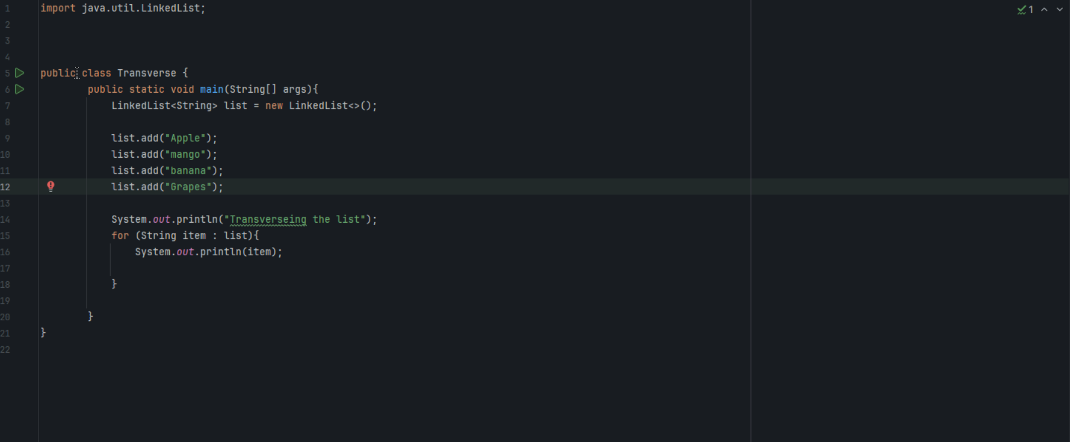

Task02

Traversing elements :

Traversing in Data structure signifies visiting or accessing each element in a data structure systematically. Generally, it is in such a way that each element is at least visited once. It is iterating over all the elements of the data structure.

Task05

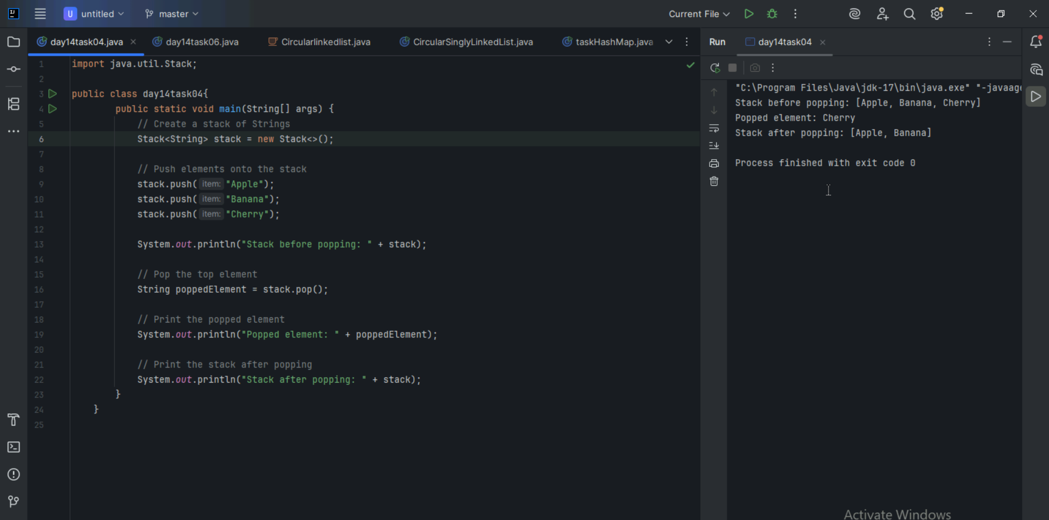

Task06

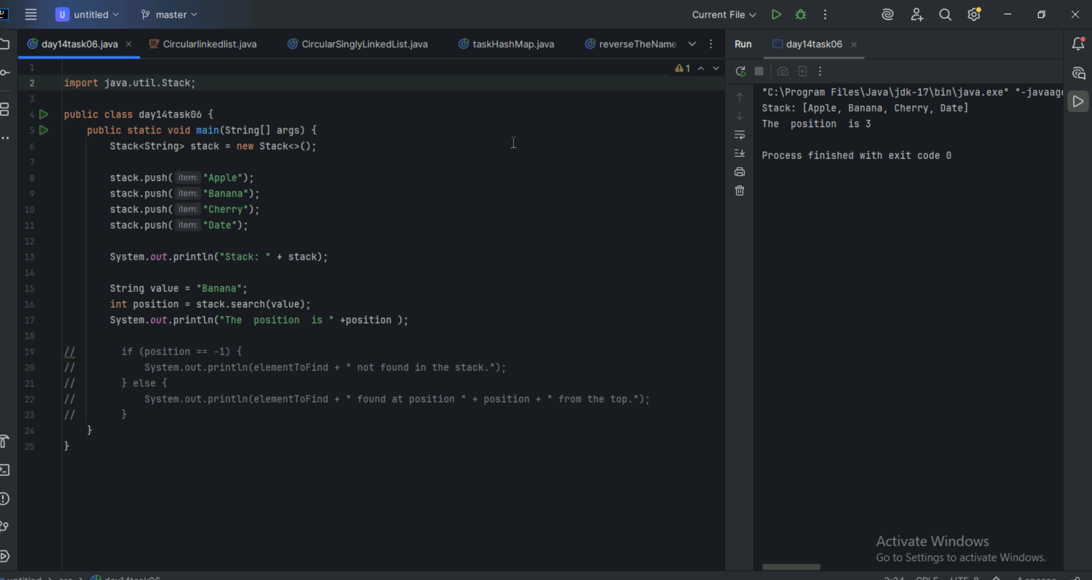

Task07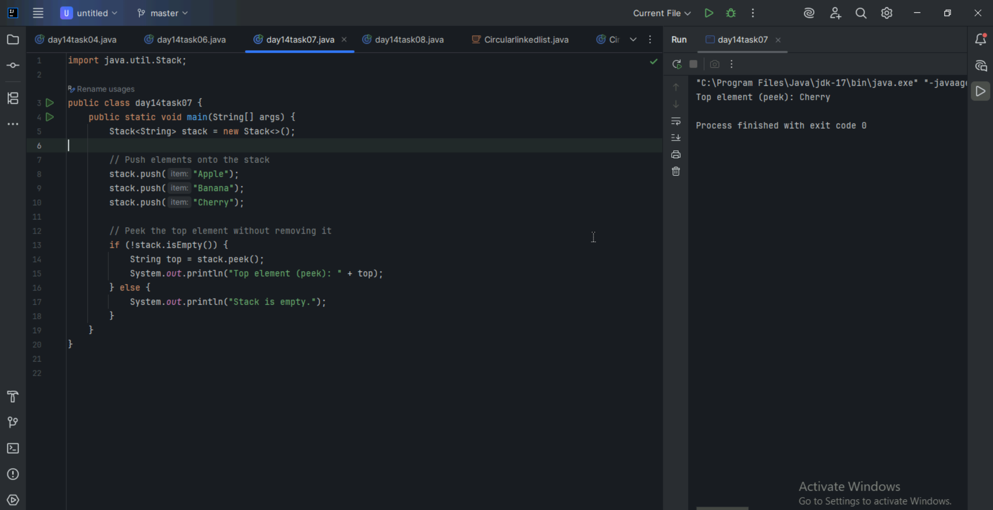

Task08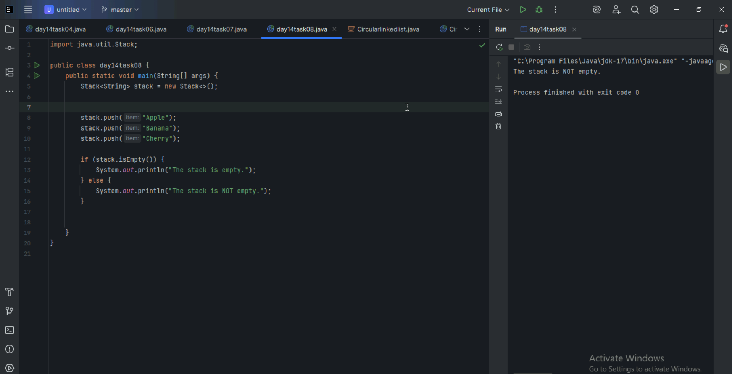

Task 09 :What are the methods of the stack class.. List them down.. With a one liner..

• **push(E item)** – Adds an item to the top of the stack.

• **pop()** – Removes and returns the top item from the stack.

• **peek()** – Returns the top item without removing it from the stack.

• **empty()** – Checks if the stack is empty (returns true or false).

• **search(Object o)** – Returns the 1-based position of an item from the top; -1 if not found.

• **size()** – Returns the number of elements in the stack (inherited from Vector).

• **isEmpty()** – Checks if the stack contains no elements (inherited from Vector).

• **clear()** – Removes all elements from the stack (inherited from Vector).

• **get(int index)** – Returns the element at a specific index (inherited from Vector).

• **iterator()** – Returns an iterator over the elements in the stack.